CRYPTOGRAPHY LABORATORY
Record of Programs

NAME: MOHAMED IRFAN .N
REGISTER NUMBER: 192521473
COURSE CODE: CSA5112
COURSE NAME: CRYPTOGRAPHY AND NETWORK SECURITY

EX. NO: 1

CAESAR CIPHER

Aim:
To write a C program to implement the Caesar Cipher, a classical substitution technique, for encrypting a given plaintext using a fixed key value.
Algorithm:
- Start the program.
- Read the plaintext and the key (shift value) from the user.
- Traverse each character of the plaintext.
- If the character is an uppercase letter, shift it circularly within 'A' to 'Z' by the key value.
- If the character is a lowercase letter, shift it circularly within 'a' to 'z' by the key value.
- If the character is not an alphabet, leave it unchanged.
- Display the resulting encrypted text.
- Stop the program.
Program:
#include <stdio.h>
#include <string.h>
#include <ctype.h>

int main() { char text[100]; int key;

printf("Enter plaintext: "); scanf("%s", text); printf("Enter key: "); scanf("%d", &key);

printf("\nEncrypted Text: "); for (int i = 0; i < strlen(text); i++) { char ch = text[i]; if (isupper(ch))
printf("%c", ((ch - 'A' + key) % 26) + 'A'); else if (islower(ch))
printf("%c", ((ch - 'a' + key) % 26) + 'a'); else
printf("%c", ch);
}
printf("\n"); return 0;
}
Output:
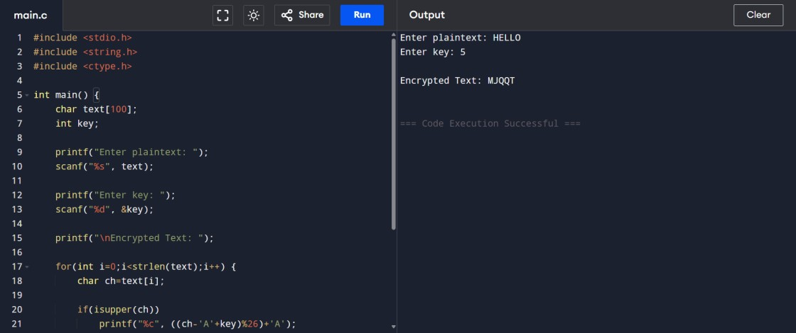
Result:
Thus a C program to implement the Caesar Cipher encryption technique was written, executed and the output was verified successfully.
EX. NO: 2

MONOALPHABETIC CIPHER

Aim:
To write a C program to implement the Monoalphabetic Cipher, which encrypts a plaintext using a fixed substitution key derived from a permutation of the alphabet.
Algorithm:
- Start the program.
- Define a substitution key array containing a permutation of the twenty-six letters of the alphabet.
- Read the plaintext from the user.
- Convert each character of the plaintext to uppercase.
- For every alphabetic character, replace it with the character present at the corresponding position in the substitution key.
- Leave non-alphabetic characters unchanged.
- Display the encrypted text.
- Stop the program.
Program:
#include <stdio.h>
#include <string.h>
#include <ctype.h>

int main() { char plain[100];
char key[] = "QWERTYUIOPASDFGHJKLZXCVBNM";

printf("Enter Plain Text: "); scanf("%s", plain);

printf("Encrypted Text: ");
for (int i = 0; i < strlen(plain); i++) { char ch = toupper(plain[i]); if (ch >= 'A' && ch <= 'Z') printf("%c", key[ch - 'A']); else
printf("%c", ch);
}
printf("\n"); return 0;
}
Output:
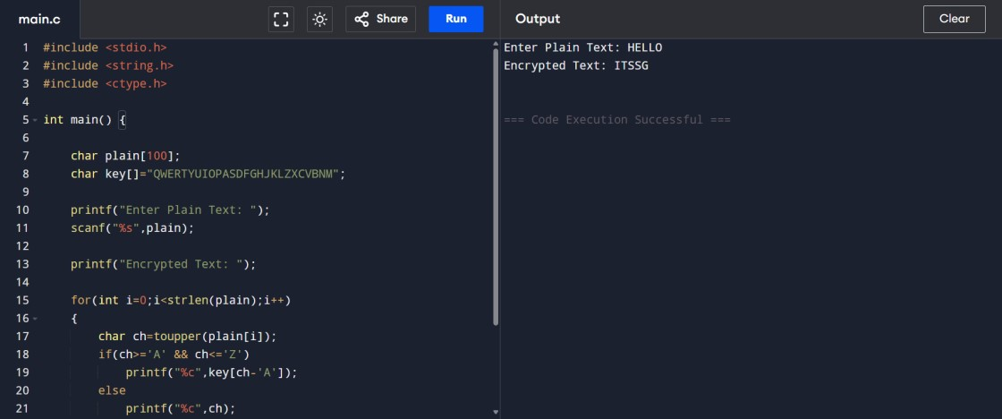
Result:
Thus a C program to implement the Monoalphabetic Cipher using a substitution key was written, executed and the output was verified successfully.
EX. NO: 3

POLYALPHABETIC CIPHER (VIGENERE CIPHER)

Aim:
To write a C program to implement the Vigenere Cipher, a polyalphabetic substitution technique that uses a repeating keyword to encrypt the plaintext.
Algorithm:
- Start the program.
- Read the plaintext and the keyword from the user.
- Determine the length of the plaintext and the length of the keyword.
- For every character in the plaintext, convert both the plaintext character and the corresponding keyword character (repeated cyclically) to uppercase.
- Compute the cipher character using the relation (plaintext value + key value) mod 26.
- Display the resulting encrypted text.
- Stop the program.
Program:
#include <stdio.h>
#include <string.h>
#include <ctype.h>

int main() {
char text[100], key[100];

printf("Enter Plain Text: "); scanf("%s", text); printf("Enter Key: "); scanf("%s", key);

int len = strlen(text); int keylen = strlen(key);

printf("Encrypted Text: "); for (int i = 0; i < len; i++) { char ch = toupper(text[i]); char k = toupper(key[i % keylen]); char enc = ((ch - 'A') + (k - 'A')) % 26 + 'A'; printf("%c", enc);
}
printf("\n"); return 0;
}
Output:
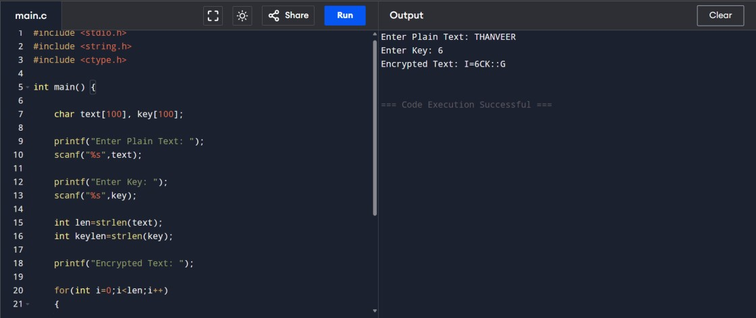
Result:
Thus a C program to implement the Vigenere Cipher, a polyalphabetic substitution technique, was written, executed and the output was verified successfully.

EX. NO: 4

HILL CIPHER (2 X 2 MATRIX)
Aim:
To write a C program to implement the Hill Cipher, a polygraphic substitution technique, using a 2 x 2 key matrix for encryption.
Algorithm:
- Start the program.
- Read the elements of the 2 x 2 key matrix from the user.
- Read two letters of the plaintext and convert them into their numeric equivalents (A = 0, B = 1, ... , Z = 25).
- Multiply the key matrix with the plaintext vector to obtain the cipher vector.
- Reduce each element of the cipher vector modulo 26.
- Convert the resulting numeric values back into their corresponding letters.
- Display the encrypted text.
- Stop the program.
Program:
#include <stdio.h>

int main() { int key[2][2]; char text[3]; int p[2], c[2];

printf("Enter 2x2 Key Matrix:\n"); for (int i = 0; i < 2; i++) for (int j = 0; j < 2; j++) scanf("%d", &key[i][j]);

printf("Enter Plain Text (2 letters): "); scanf("%s", text);

p[0] = text[0] - 'A'; p[1] = text[1] - 'A';

c[0] = (key[0][0] * p[0] + key[0][1] * p[1]) % 26; c[1] = (key[1][0] * p[0] + key[1][1] * p[1]) % 26;

printf("Encrypted Text: ");
printf("%c%c\n", c[0] + 'A', c[1] + 'A'); return 0;
}
Output:
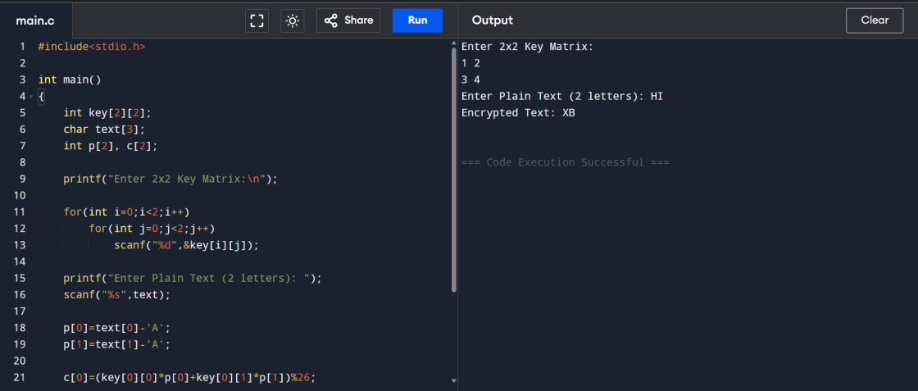
Result:
Thus a C program to implement the Hill Cipher using a 2 x 2 key matrix was written, executed and the output was verified successfully.
EX. NO: 5

PLAYFAIR CIPHER
Aim:
To write a C program to implement the Playfair Cipher, a digraphic substitution technique that encrypts pairs of letters using a 5 x 5 key matrix.
Algorithm:
- Start the program.
- Construct a 5 x 5 key matrix using the keyword "PLAYFAIR", combining the letters I and J into a single cell.
- Read a pair of plaintext letters from the user.
- Locate the row and column positions of both letters within the key matrix.
- If both letters lie in the same row, replace each with the letter immediately to its right, wrapping around the row if required.
- If both letters lie in the same column, replace each with the letter immediately below it, wrapping around the column if required.
- If the letters lie in different rows and columns, replace each letter with the one in its own row but in the column of the other letter (rectangle rule).
- Display the resulting encrypted pair of letters.
- Stop the program.
Program:
#include <stdio.h>
#include <string.h>
#include <ctype.h>

char matrix[5][5] = { {'P', 'L', 'A', 'Y', 'F'},
{'I', 'R', 'E', 'X', 'M'},
{'B', 'C', 'D', 'G', 'H'},
{'K', 'N', 'O', 'Q', 'S'},
{'T', 'U', 'V', 'W', 'Z'}
};

void find(char c, int *r, int *col) { if (c == 'J') c = 'I';
for (int i = 0; i < 5; i++) { for (int j = 0; j < 5; j++) { if (matrix[i][j] == c) {
*r = i;
*col = j;
}
}
}
}

int main() { char text[100];
printf("Enter Plain Text (2 letters): "); scanf("%s", text);

int r1, c1, r2, c2;
find(toupper(text[0]), &r1, &c1); find(toupper(text[1]), &r2, &c2);

if (r1 == r2) {
printf("Encrypted Text: %c%c\n", matrix[r1][(c1 + 1) % 5], matrix[r2][(c2 + 1) % 5]);
} else if (c1 == c2) {
printf("Encrypted Text: %c%c\n", matrix[(r1 + 1) % 5][c1], matrix[(r2 + 1) % 5][c2]);
} else {
printf("Encrypted Text: %c%c\n", matrix[r1][c2], matrix[r2][c1]);
}
return 0;
}
Output:
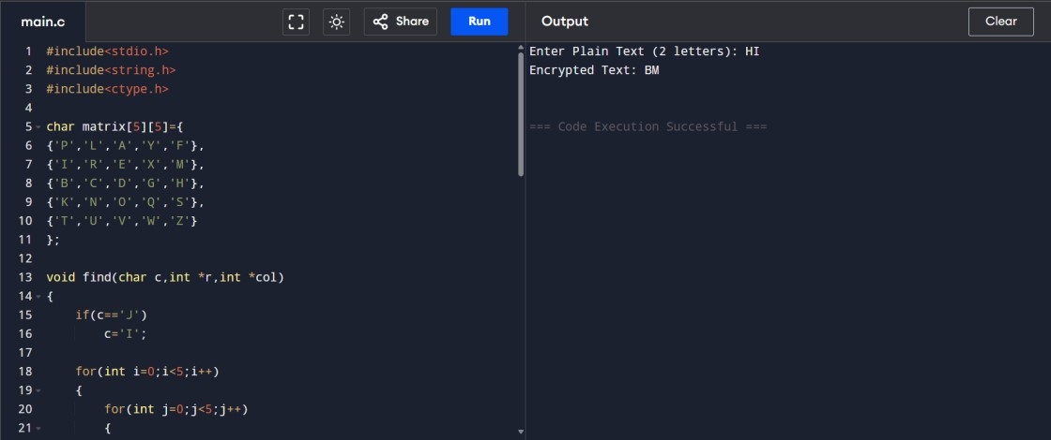
Result:
Thus a C program to implement the Playfair Cipher using a 5 x 5 key matrix was written, executed and the output was verified successfully.
EX. NO: 6

RAIL FENCE CIPHER
Aim:
To write a C program to implement the Rail Fence Cipher, a transposition technique that rearranges plaintext characters in a zig-zag pattern across a defined number of rails.
Algorithm:
- Start the program.
- Read the plaintext and the number of rails from the user.
- Create a two-dimensional matrix with rows equal to the number of rails and columns equal to the length of the plaintext.
- Traverse the plaintext and place each character into the matrix, moving down and up across the rails in a zig-zag manner.
- Read the matrix row by row, skipping empty cells, to obtain the encrypted text.
- Display the resulting encrypted text.
- Stop the program.
Program:
#include <stdio.h>
#include <string.h>

int main() { char text[100]; int key;

printf("Enter Plain Text: "); scanf("%s", text);
printf("Enter Number of Rails: "); scanf("%d", &key);

int len = strlen(text); char rail[key][len];

for (int i = 0; i < key; i++) for (int j = 0; j < len; j++) rail[i][j] = '\n';

int row = 0; int dir = 1;
for (int i = 0; i < len; i++) { rail[row][i] = text[i]; if (row == 0) dir = 1;
else if (row == key - 1)
dir = -1; row += dir;
}

printf("Encrypted Text: "); for (int i = 0; i < key; i++) for (int j = 0; j < len; j++) if (rail[i][j] != '\n') printf("%c", rail[i][j]); printf("\n"); return 0;
}
Output:
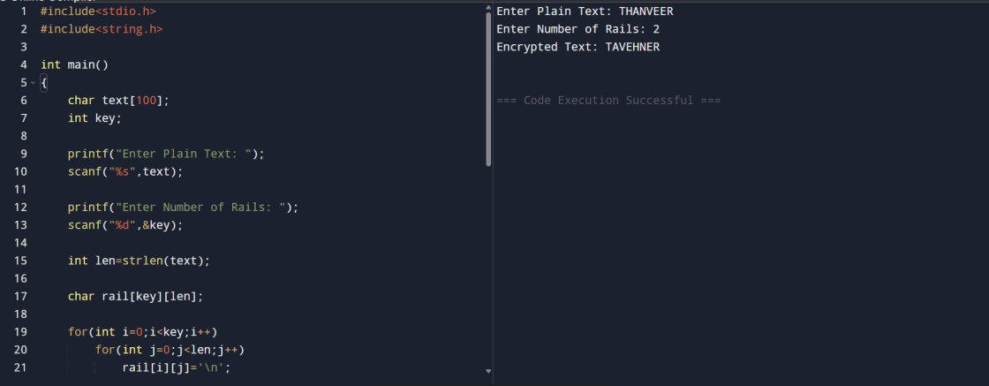
Result:
Thus a C program to implement the Rail Fence Cipher transposition technique was written, executed and the output was verified successfully.

EX. NO: 7

COLUMNAR TRANSPOSITION CIPHER

Aim:
To write a C program to implement the Columnar Transposition Cipher, a transposition technique that rearranges plaintext characters by reading a filled matrix column by column.
Algorithm:
- Start the program.
- Read the plaintext and the number of columns from the user.
- Calculate the number of rows required to accommodate the plaintext.
- Fill the matrix row-wise with the characters of the plaintext, padding any remaining cells with the letter 'X'.
- Read the matrix column by column to generate the encrypted text.
- Display the resulting encrypted text.
- Stop the program.
Program:
#include <stdio.h>
#include <string.h>

int main() { char text[100]; int cols;

printf("Enter Plain Text: "); scanf("%s", text);
printf("Enter Number of Columns: "); scanf("%d", &cols);

int len = strlen(text);
int rows = (len + cols - 1) / cols; char matrix[20][20]; int k = 0;

for (int i = 0; i < rows; i++) { for (int j = 0; j < cols; j++) { if (k < len)
matrix[i][j] = text[k++]; else
matrix[i][j] = 'X';
}
}

printf("Encrypted Text: ");
for (int j = 0; j < cols; j++) { for (int i = 0; i < rows; i++) printf("%c", matrix[i][j]);
}
printf("\n"); return 0;
}
Output:
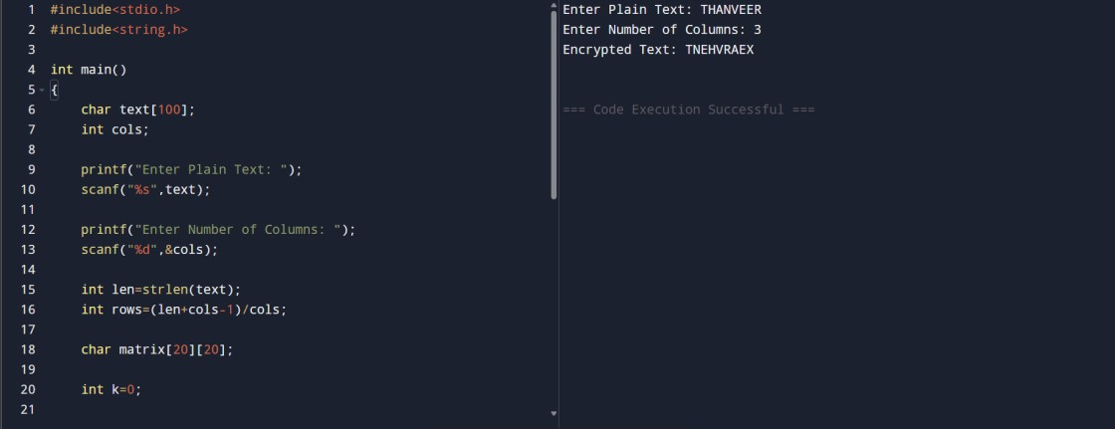
Result:
Thus a C program to implement the Columnar Transposition Cipher was written, executed and the output was verified successfully.

